# RESUME

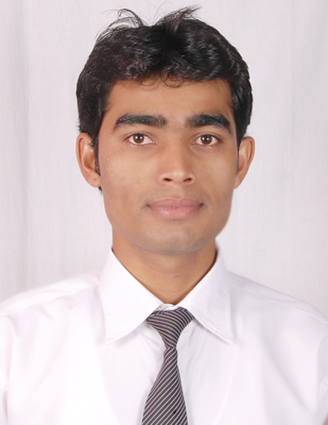

**Name: GAVHANE DNYANESHWAR UDDHAVRAO**

**E-mail:**[**dnyan2706@gmail.com**](mailto:dnyan2706@gmail.com)

**MobileNo.: +91 9552425943**

|  |
| --- |
| **Objective:** |
| To obtain the knowledge for better development of organization by using my skills and willing contribute towards the progress of society welfare through the position acquired. | |

|  |
| --- |
| **Work Experience** |
| **Teradata** | Working as Database specialist in Global Support Organization Base Team from last 2 years and 3 months. |

|  |  |
| --- | --- |
| **Educational Qualification:** | |
| **Degree** | **College** | | **University** | **Grade** |
| **B.Tech.(ECE)** | SRES College of engineering, Kopargaon. | | Pune University | Distinction |

|  |
| --- |
| **Technical skills:** |
| **Operating Systems** | Good knowledge of Linux. |
| **Programming skills** | C, C++ |
| **Networking skills** | TCP/IP, UDP. |
| **Hadoop skills** | Data loading tools like Flume, Sqoop also having Cognitionof Pig, Hive, MapReduce/YARN, R Connectors, Ozzie, HDFS, Zookeeper and Hbase. |
| **Serial communication protocol** | UART, SPI, I2C. |

|  |
| --- |
| **Achievements;** |
| * Cleared Teradata 14 Certification exam. (TD 14 Certified professional program) * Secured 1st rank in State level circuit debugging at CHOISEN-2013, organized by Vishwabharati Academy’s COE Ahmednagar. * Distinction in B.Tech from Pune University. | |

|  |
| --- |
| **Extra-Curricular Activities:** |
| 1. Member of N.S.S. (National Service Scheme) 2. Member of C.S.R. (Corporate Social Responsibility) organized by Teradata | |

|  |
| --- |
| **Personal Information:** |
| **Name** | **GAVHANE DNYANESHWAR UDDHAVRAO** |
| **Date of Birth** | 27 June 1992 |
| **Marital Status** | Single |
| **Nationality** | Indian |
| **Contact Phone** | (M) +91-9552425943, +91-9011825752 |
| **Email** | [dnyan2706@gmail.com](mailto:dnyan2706@gmail.com) |

**Declaration: -**

I hereby certify that the information furnished above is true as per my knowledge.

Place: Hyderabad.

**(Gavhane Dnyaneshwar)**